COMP4136: Visible Face Recognition
JIA Man Qi Vivian, 23033073D
HEO Sunghak, 21097305D

Phase I: Detailed Study
Visible Face Recognition: A Biometric Modality
Currently, the state-of-the-art in performance within the biometric modality of visible face recognition include ArcFace, FaceNet, VGG-Face, CurricularFace and more. The two algorithms to be examined in this report are ArcFace and CurricularFace respectively.
ArcFace, or Additive Angular Margin Loss, is utilized as a method for deep face recognition that extrapolates highly distinctive features from faces for facial recognition, through using DCNN (Deep Convolutional Neural Networks). It outperformed most state-of-the-art methods with comprehensive tests.
Adaptive Curriculum Learning Loss, also known as CurricularFace, adapts a curricular learning process in its loss functions, with emphasis on simple and hard samples, to address the issue of such samples during the early training stage that may lead to convergence. As such, the samples are categorized according to difficulty and importance in different training stages.

Examples and Applications
Visible face recognition as a biometric modality is used in all kinds of real-life scenarios, both in civilian and forensic applications in recent years. Day-to-day application includes the face recognition built into modern phones that all consumers use for privacy reasons, for entry and exit in school punch-in, company clock-in, and more.
Face recognition has also been adapted in more official settings such as airports and at borders. The Hong Kong International Airport had introduced Flight Tokens, a self-service biometric system that integrates multiple passenger departure checkpoints seamlessly. Flight Tokens work at smart check-in kiosks, baggage drops, e-channels for security and boarding gates, and more. The TSA (Transportation Security Administration) also employs facial recognition technology as part of their risk-based approach in transportation screening. In 2022, the TSA employed CAT-2, the second generation of Credential Authentication Technology at Denver International Airport, which takes a real-time photo of a passenger and compares it to the identification credential, completing after a TSA officer verifies the authenticity. This greatly reduces the amount of time needed for screening. Furthermore, Hong Kong has also adopted facial recognition technology at Shau Tau Kok border checkpoint towards the mainland, making contactless screening a reality.
This biometric modality extends to forensic applications as well. Forensic face recognition (FFR) is applied in law enforcement to increase the efficiency and effectiveness of workflow. FFR is frequently applied to survey and investigate criminal activities in surveillance camera footage or images of crime scenes, with a significant advantage due to the ability to analyze large volumes of footage. FFR is used in the identification of suspects, victims and repeat offenders, as well as aid in the search for missing persons or provide insights into cold cases.
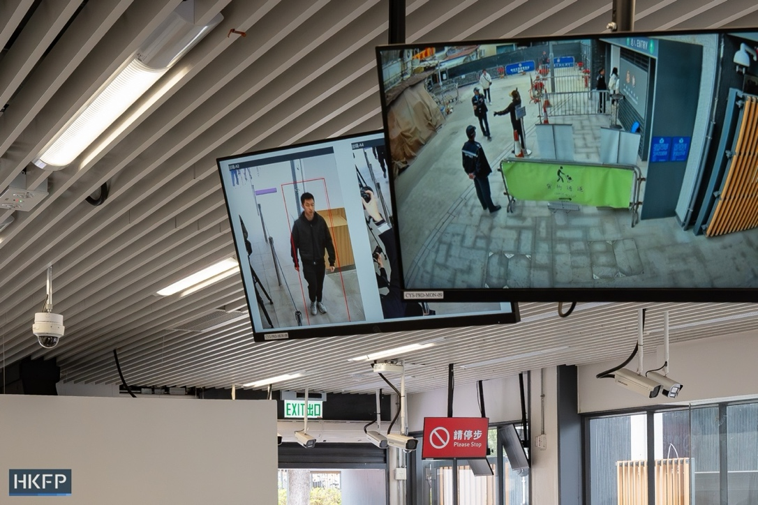
Fig 1. Chung Ying Street checkpoint at Sha Tau Kok adopting contactless facial recognition technology. Photo: Kyle Lam, HKFP

Publicly Available Databases
There are many publicly available databases, including CelebA, MegaFace, LFW (Labeled Faces in the Wild), CASIA-WebFace, and more. However, CelebA and MegaFace are the more commonly used datasets.
CelebA, or Large-scale CelebFaces Attributes Dataset, is a large-scale facial attribute database with more than 200,000 celebrity images, each with 40 attribute landmarks, which coalesce into a total of around 10,000 different identities. This database is known for its landmarks and annotations that make it a versatile database for face and facial attribute recognition, detection, and more.
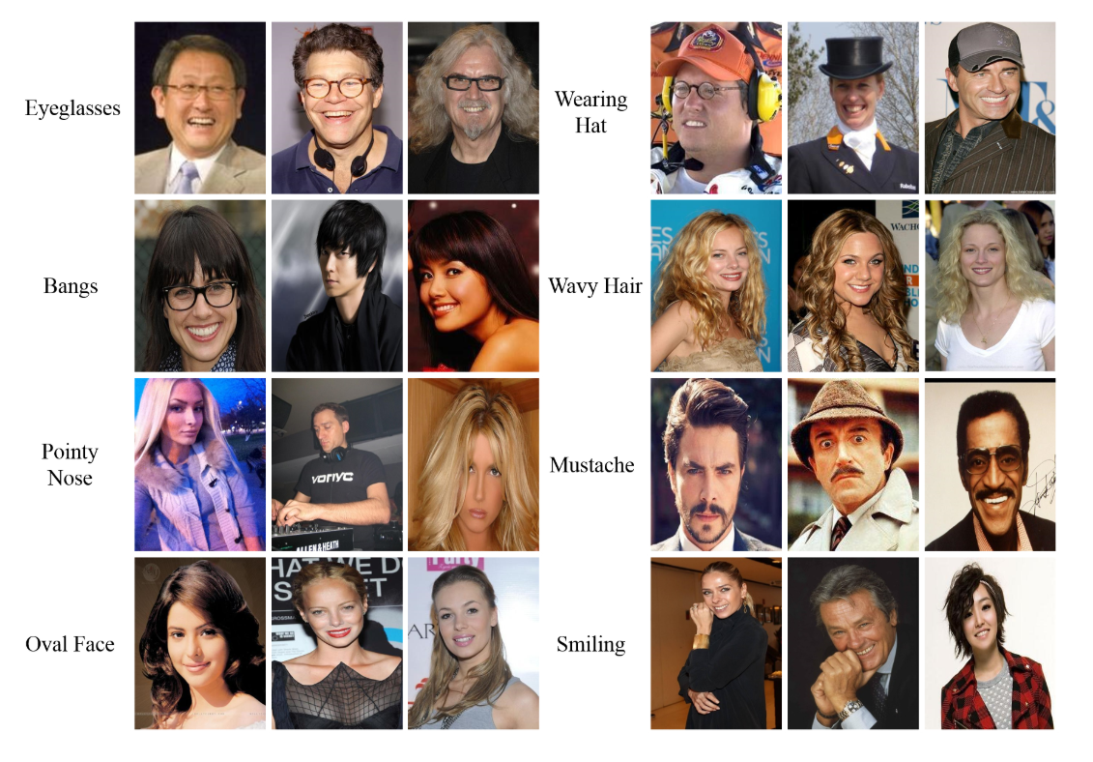
Fig 2. Example of CelebA’s attribute annotations. Image: CelebA
MegaFace is a large-scale database and benchmark whose main goal is to evaluate and encourage development of facial recognition algorithms at scale [6]. For its training set, it boasts over 4 million photos, with around 670,000 unique identities from the web, and an average of seven photos per unique person, with 3 minimum and 2469 being the maximum amount. Because of MegaFace’s purpose as a facial recognition algorithm evaluation database, there is also a “distractor” set not a part of the probe set, including up to one million photos with 690,000 identities. However, MegaFace is currently decommissioned, and its database is no longer in distribution due to the strain of administrative management.

Acquisition and Standardization
Facial recognition has standardized recommendations due to the versatility of its usage and application to various devices.
ISO/IEC 19794-5 is a standard that “specifies a record format for storing, recording, and transmitting information from one or more facial images or a short video stream of facial images” [7]. It is part of the ISO, or the International Organization for Standardization’s guidelines regarding biometric formatting. There are certain specifications for travel documents, discussed by the ICAO (International Civil Aviation Organization) according to the standard formats as designated by the ISO. These requirements are implemented to correctly execute detailed human examination of small features, identity by comparison, and computer-automated identification and verification. To enable the versatility of application on various devices, there are implementations for scenic restraints, image attributes, and photographic properties, including but not limited to pose, expression, lighting, focus, resolution, size, and more. Some examples are whether the person is centered in a photograph, whether the background is uniform, and if there are any objects obstructing the features of a person.
HikVision is a company that sells face recognition terminals with a touch-free, contactless experience for higher security and more convenience. The standardizations include extensive, versatile functionality within one device that’s easy to operate and includes top-level security. Functions for anti-spoofing, data encryption, and more extensive privacy protection.
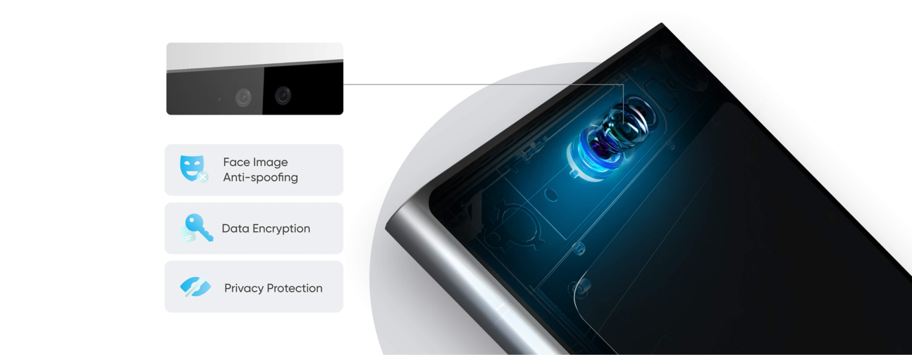
Fig 3. Image of HikVision product standards. Image: HikVision Face Recognition Terminals
Another company, Modivision, defines some requirements for a perfect environment for biometric facial recognition. Their requirements consider the average varying heights of consumers, that contribute to the distance the terminal should be from the person. Since a person’s average height varies from 1.2 meters to 2.2 meters, if the camera is only 0.5 meters away from a person, the camera only has a span of half a meter to work with. This means, in this example, there needs to be a consideration for the angle of multiple cameras or the tilting of existing ones. The places a face recognition terminal or kiosk could exist in vary from well-lit areas to dark corners, so focused illumination should be considered. To avoid confusion between the target person and a possible crowd behind them, a built-in measurement system is required to determine the position of the target face to be recognized. Systems should also be wired to accommodate the intuitive behavior of humans that minimizes confusion related to the system and speeds up the process. Most importantly, since a normal camera cannot distinguish between a real face and a face on a flat image, the distinction between authentic faces and false ones should be taken into consideration.

Phase II: Performance Evaluation
Among the introduced face recognition algorithms earlier, we conduct a performance evaluation of two state-of-the-art face recognition algorithms: Arcface and CurricularFace. Both models are widely used in modern biometric systems and are known for their high accuracy in face recognition applications. Therefore, we expect both models to deliver highly accurately.
To briefly explain how both models work, they are processed in four steps. They first find the location of the face in the image. Next, they extract key facial points - such as the eyes, mouth, and nose - to align the face and resize to facilitate embedding extraction. They use deep convolutional neural networks to extract 512-dimensional embeddings from the face. Then, these embeddings are compared by cosine-similarity, which is proven to be the most suitable distance metric for this experiment.
The main difference between the two models is loss-functions as explained at the beginning. Arcface uses Additive Angular Margin Loss, which leads to clearer separation, while CurricularFace uses the technique that dynamically selects easy samples first to learn more robust and generalized features.
To fairly compare the two models, we selected the same dataset called “Labeled Faces in the Wild (LFW)”, which is a widely used and well-organized dataset for face recognition containing 13000+ images for 5700+ identities and conducted experiments in the same way. Since our goal is to test the models rather than train them, the dataset was sufficiently large and clear for evaluation purposes.
Our experiment consists of two settings: in the first one, for each of 200 distinct identities, we extracted embeddings from three different images and stored them in the gallery (sess1) and two probes (sess2 and sess3), resulting in 200x3 = 600 images in total. This setting 400 genuine pairs (200 x 2 = 400) and 79600 imposter pairs (400 x 199 = 79600). In the second setting, for each of the 300 unique identities, we extracted embeddings from four different images, dividing them into gallery (sess1) and three probes (sess2, sess3, and sess3), resulting in 300x4 = 1200 images in total. This led to 900 genuine pairs (300x3 = 900) and 269,100 imposter pairs (300x899 = 269,100). Due to the limited computational power, we could not try with more test images. Lastly, we compared the two models from the results of the previous two settings.
The purpose of this experiment is to evaluate the performances of these algorithms using the three evaluation metrics: Receiver Operating Characteristics (ROC) curve, Cumulative Match Characteristics (CMC) curve, and False Positive Identification Rate (FPIR) and False Negative Identification Rate (FNIR). ROC curve shows the relationship between false accept and true accept rates. CMC curve identifies identification accuracy according to ranks, which indicates how early the correct identity is retrieved when all candidates are ranked based on similarity — a higher rank means better performance. FPIR/ FNIR appears the rate at which unauthorized identities are accepted and authorized ones are rejected.

Setting 1
As mentioned earlier, this setting shows the results from Arcface and CurricularFace on a subset of 200 identities, each with 3 different images. This setting was enough to evaluate the performances of both models.
The ROC curve below indicates a great Genuine Accept Rate (GAR) at a low False Accept Rate (FAR), which implies that Arcface successfully separated genuine and imposter pairs, and this feature can be found in the cosine similarity distribution graph in {Appendix}. The curve starts from the top left corner and slowly approaches 1.00. The CMC curve below displays that Arcface achieved over 96% accuracy at rank 1, which means it retrieves the correct match at a very high priority in most cases.
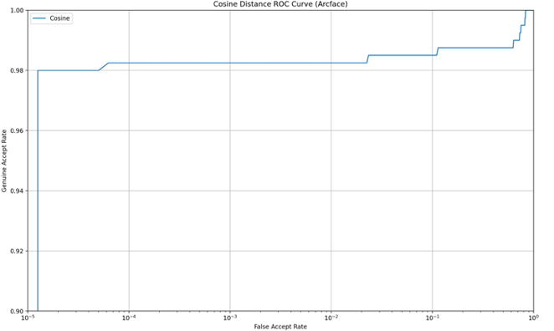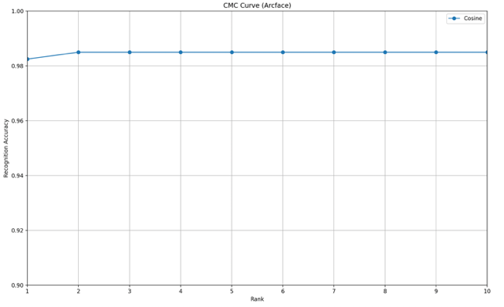
Fig 4. ROC and CMC Curve for Arcface in Setting 1
The FPIR vs FNIR curve below represents the inversely proportional relationship between FPIR and FNIR. As the system becomes more conservative, FNIR gets significantly low. This graph implies that Arcface has a minute chance to misidentify an imposter as a registered identity, whereas still verifies registered identities correctly. Additionally, the Equal Error Rate (EER), the point where FAR equals FRR, was recorded at 1.75%, and the Decidability Index (DI), a score that indicates how to separate the genuine and imposter distributions, was recorded at 6.19, which are generally considered as a nearly perfect model.
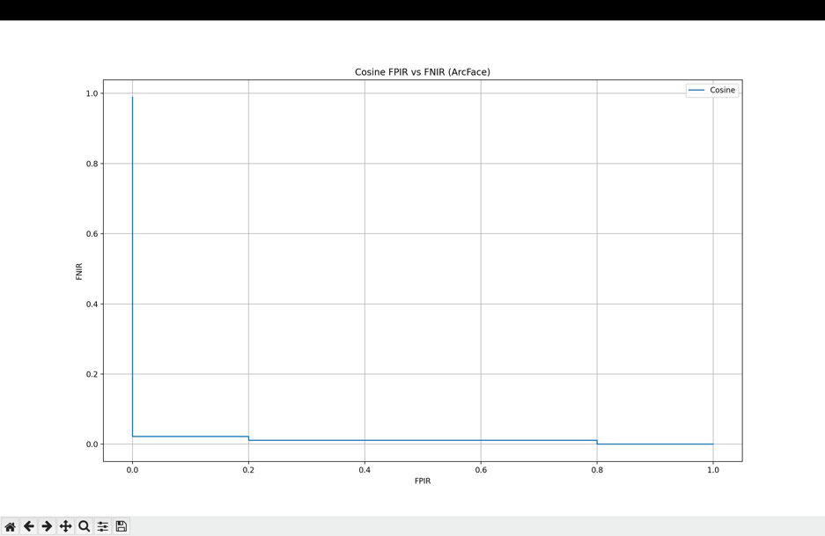
Fig 5. FPIR/FNIR Curve for Arcface in Setting 1
Next, we will evaluate the performance of CurricularFace. The graphs between the two models look very similar. The ROC curve starts at 98% of GAR from the very low rate of FAR. The CMC curve also signifies 98% accuracy at rank 1, which means that this model predicts the right match at once for most cases. The CMC curve shows a meaningful increase at rank 4, meaning that some correct identities are retrieved slightly later than Arcface, which had a very flat line from the beginning of the graph. However, CurricularFace still presents reliable performance.
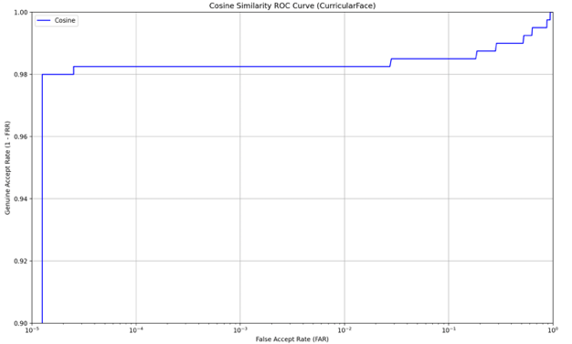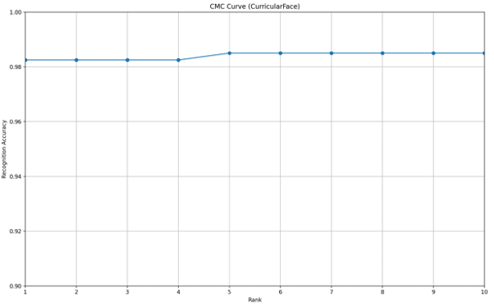
Fig 6. ROC and CMC Curve for CurricularFace in Setting 1
The FPIR/FNIR curve for CurrcularFace resembles that of Arcface. It has a desirable pattern that sharply drops in FPIR with a slight increase in FNIR and keeps nearly zero FNIR throughout the range of FPIR. In addition, CurricularFace shows an EER of 1.77 and DI of 6.79, which is also considered excellent as Arcface.
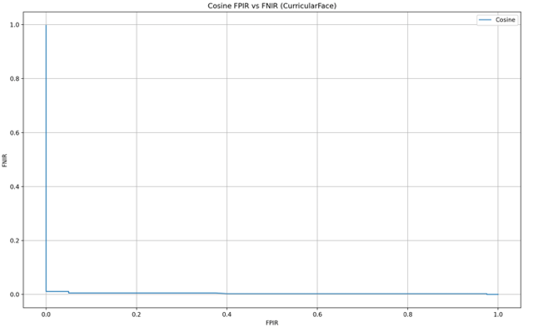
Fig 7. FPIR/FNIR Curve for CurricularFace in Setting 1
In summary, both Arcface and CurricularFace models perform highly accurately under the 200*3 dataset, which may seem to be small yet enough. This could be accomplished by LFW, which is well-known to be an aligned, light, and clear set of face images. In {Appendix}, the merged version of the graphs for both models is prepared. Both models ideally approached the top-left corner of the ROC curve. Arcface achieved an EER of 1.75%, while CurricularFace recorded an EER of 1.77%. Even though the difference is trivial, it suggests that Arcface performs slightly better for minimizing FAR and FRR. When evaluating the CMC curve, Arcface performed a little more stable, while CurricularFace had a few cases that were retrieved more slowly. Both models have nearly perfect FPIR/FNIR curves, so it is not reasonable to debate which one performed better. However, the gap in the Decidability Index (DI) between them reflects that CurricularFace (6.79) had a better separation between genuine and imposter pairs than Arcface (6.19). These points may imply that Arcface generally performs slightly better on the small size of the dataset. Nevertheless, there was not enough difference to compare the performances of both models because they still outperformed in this setting. Therefore, we prepared another comparison in the next setting to find a meaningful gap.

Setting 2
In this setting, Arcface and CurricularFace models are further evaluated under 300 subjects, each with 4 images. The first image per subject was used for the gallery set (sess1), and the remaining three images per subject were used as probes (sess2, sess3, and sess4). This setting provides a more rigorous environment since more test sets tend to generate lower performance on face recognition. The objective of this setting is to analyze the robustness and scalability of both models under an extended set of images, 1200 images in total for this setting.
The result from this setting shows somewhat lower performances of both models compared to the previous setting as expected. In ROC curves below (Fig7), both curves rapidly increase until the point where FAR is less than ${10}^{-4}$, but Arcface increases slightly yet visibly faster. In CMC curves, both models have an accuracy of over 96% from rank 1, but CurricularFace seems to have a slightly higher accuracy from rank 2. Moreover, Arcface recorded an EER of 3.0%, while Curricular indicated a better EER of 2.75%. These differences may suggest that CurricularFace maintains slightly better robustness under the increasing number of datasets. In terms of Decidability Index (DI), CurricularFace with 5.8 also outperformed Arcface with 5.54. As explained, a higher DI means better separability between genuine and imposter distributions.
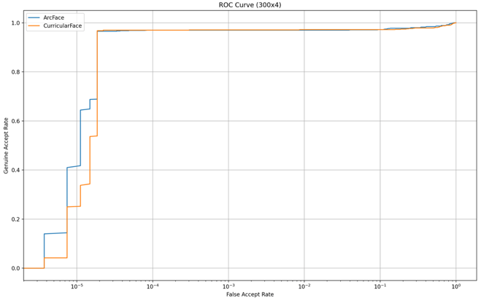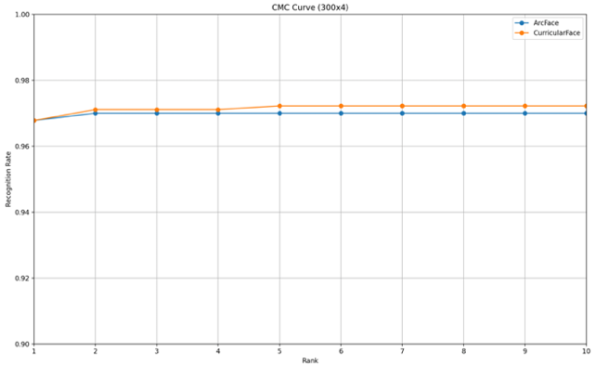
Fig 8. Merged ROC and CMC Curve for Arcface and CurricularFace
The FPIR vs FNIR graph implies that both models distinguish right registers and unregisters most time. Compared to the graph from the previous setting, it still has the same pattern. At the top left corner, a tiny gap between two curves is noticeable, but it is tiny.
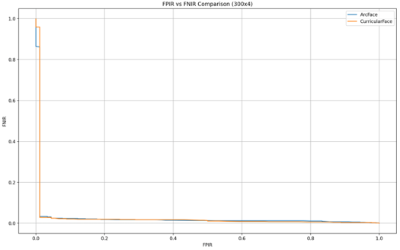
Fig 9. Merged FPIR/FNIR Curve for Arcface and CurricularFace
Overall, both Arcface and CurricularFace exhibited great performances in the 300*4 setting. Some points in the figures may be interpreted as CurricularFace performs better. This advantage may be rooted in its training technique that learns from easy and hard samples through its adaptive curriculum learning loss. However, the gap is so small that it is negligible. The reason why the gap is too minute may be considered that the since LFW dataset is highly clean, well-aligned, easy, and high-resolution, both state-of-the-art face recognition algorithms perform too accurately. Therefore, the gap in performances between the two models can be more apparent in noisier or less curated datasets, and this evaluation can be more valuable and meaningful.
Moreover, it was expected that the EER and DI values for both models deteriorated in the 300 × 4 setting compared to the 200 × 3 setting. The reason why is that the chance of having more identity pairs with similar facial features increases as the number of test images increases. Particularly, the growing number of impostor comparisons inclines to have a greater influence on the False Accept Rate (FAR), leading to slightly worse overall performance.
In conclusion, we conducted a comparative analysis of two state-of-the-art face recognition algorithms: Arcface and CurricularFace. Using the LFW dataset under two distinct settings, both models resulted in outstanding performances. Although it is plausible that CurricularFace outperformed Arcface, the overall performance was highly similar. This can be explained by the high quality and alignment of the LFW dataset. Therefore, in order to uncover discernable differences between the models, we propose that future evaluation can be more valuable by conducting evaluations under more difficult and vaguer datasets. The importance of dataset selection in face recognition is further supported by our experiment.
Appendix
Appendix A. Visual Results for ArcFace (200 × 3 Setting)
Cosine EER = 1.75%
Cosine Decidability Index = 6.19
- Cosine Similarity Distribution
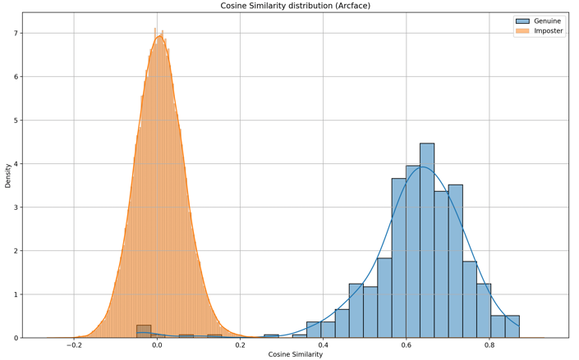
- FAR vs FRR
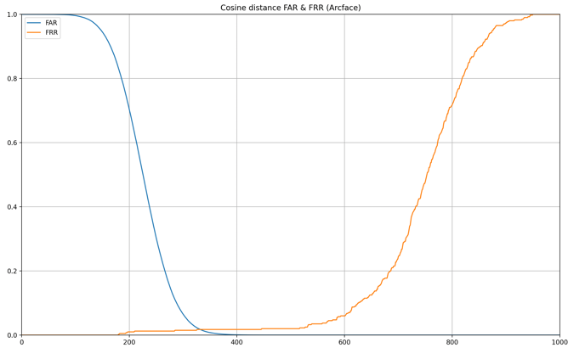
- Roc Curve
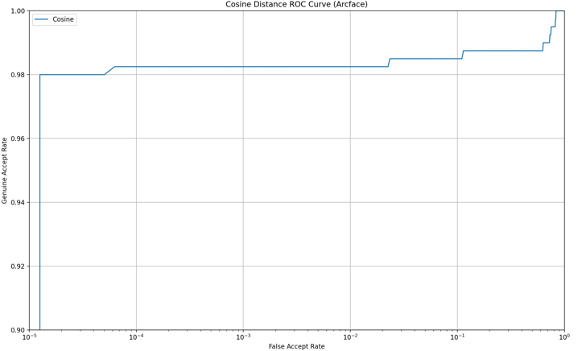
- CMC Curve
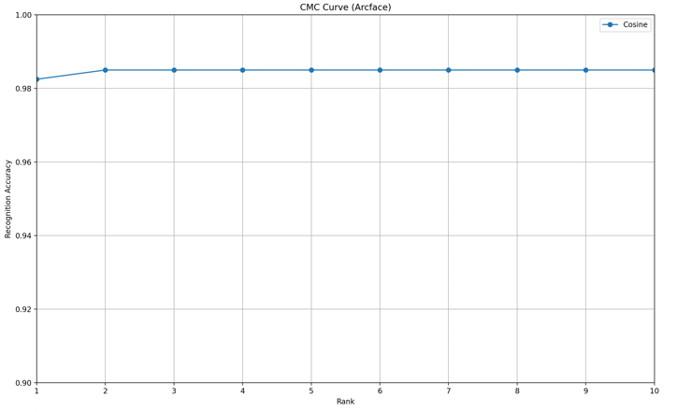
- FRIR vs FNIR
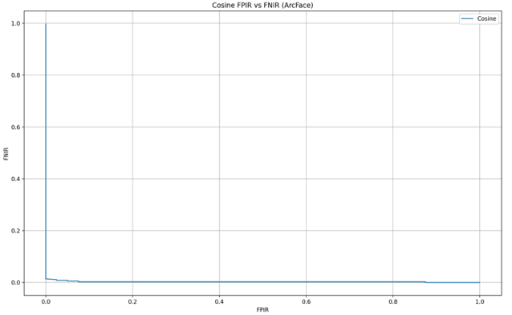

Appendix B. Visual Results for CurricularFace (200 × 3 Setting)
Cosine EER = 1.77%
Cosine Decidability Index = 6.79
- Cosign similarity distribution
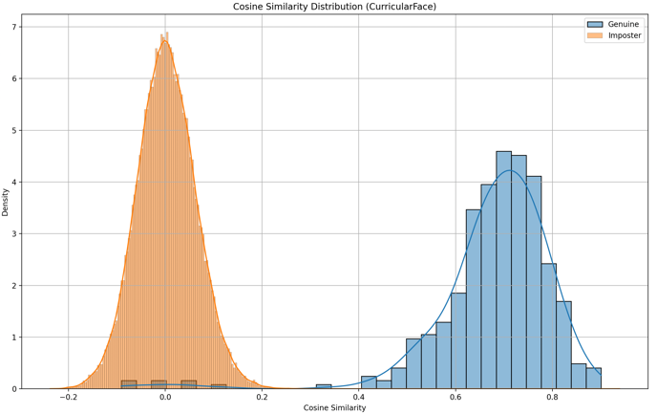
- FAR vs FRR
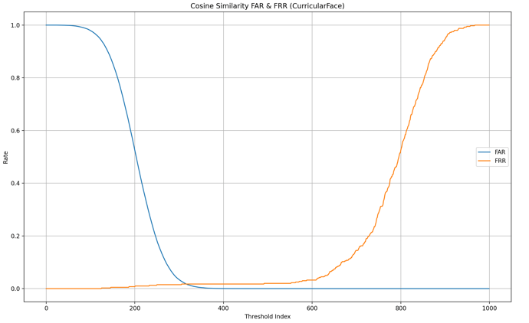
- ROC Curve
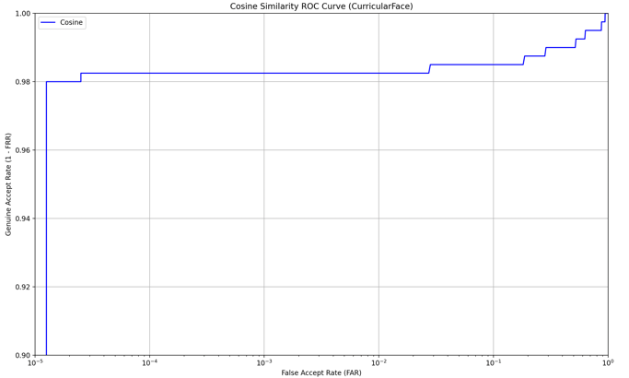
- CMC Curve
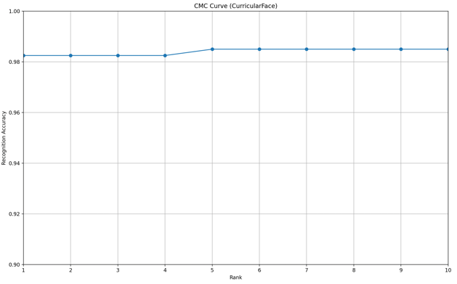
- FRIR vs FNIR
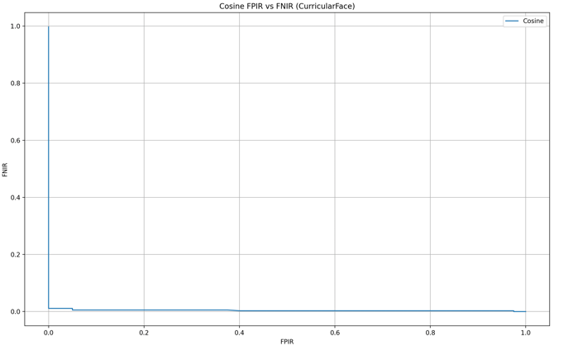

Appendix C. Visual Results for Arcface vs CurricularFace (200 × 3 Setting)
- ROC Curve
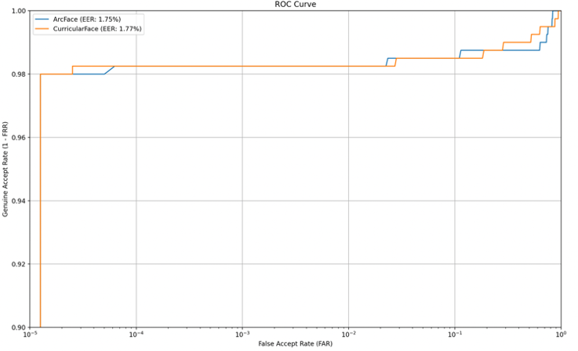
- CMC Curve
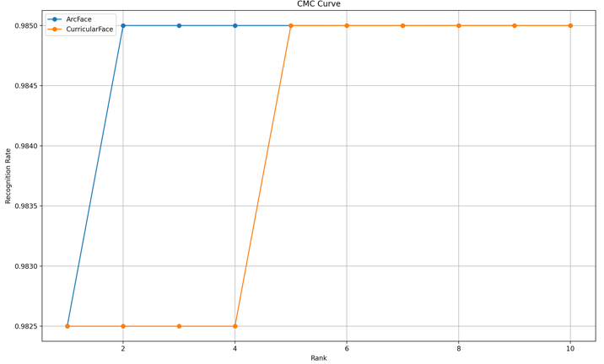
- FPIR vs FNIR
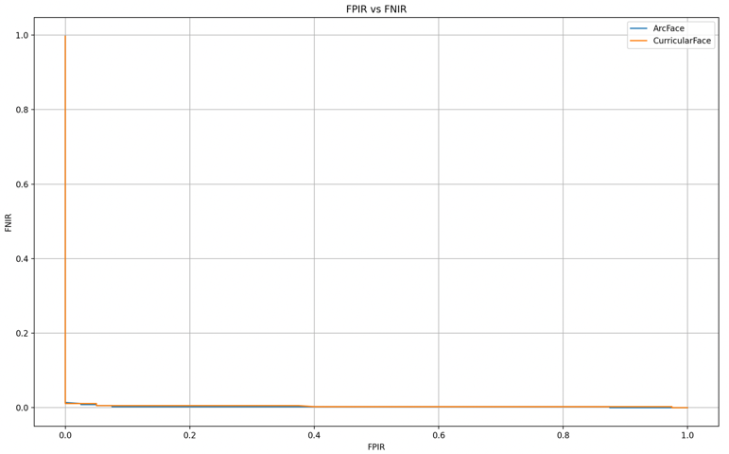

Appendix D. Visual Results for Arcface vs CurricularFace (300 × 4 Setting)
[ArcFace] EER = 3.00%, DI = 5.54
[CurricularFace] EER = 2.75%, DI = 5.8
- ROC Curve
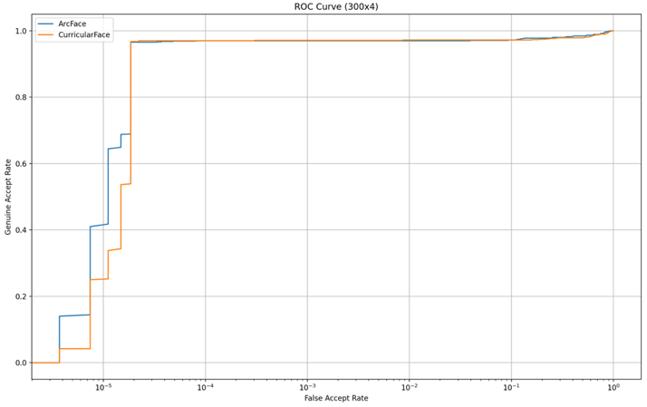
- CMC Curve
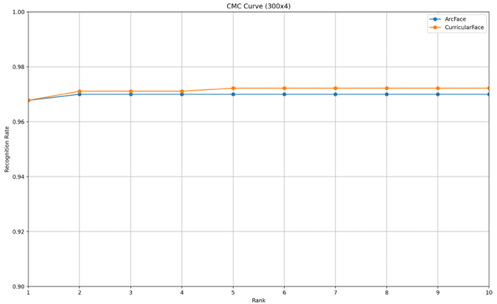
- FPIR vs FNIR
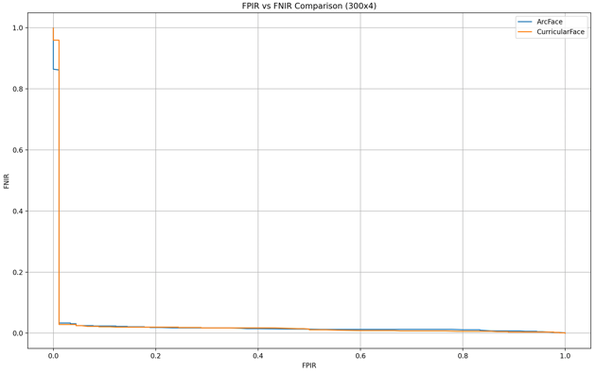

References
[1] “Face Recognition Terminals,” Hikvision, Feb. 08, 2023. Source: [Online]. Available: https://www.hikvision.com/hk/products/Access-Control-Products/Face-Recognition-Terminals/.
[2] “Flight Token, Passenger Guide,” Hong Kong International Airport. https://www.hongkongairport.com/en/passenger-guide/flight-token.page.
[3] “What are the requirements for a perfect working biometric facial recognition?”, Modivision. Source: [Online]. Available: https://www.modivision.net/wp-content/uploads/2019/08/Requirements.pdf.
[4] G. B. Huang, M. Ramesh, T. Berg, and E. Learned-Miller, October 2007, “Labeled Faces in the Wild: A Database for Studying Face Recognition in Unconstrained Environments”. University of Massachusetts, Amherst, Technical Report 07-49. Source: [Online]. Available: https://www.kaggle.com/datasets/jessicali9530/lfw-dataset.
[5] I. Chan, Hong Kong adopts facial recognition tech at Sha Tau Kok border checkpoint, Hong Kong Free Press HKFP, Dec. 24, 2024. [Online]. Available: https://hongkongfp.com/2024/12/24/hong-kong-adopts-facial-recognition-tech-at-sha-tau-kok-border-checkpoint.
[6] I. Kemelmacher-Shlizerman, S. M. Seitz, D. Miller, and E. Brossard, “The MegaFace Benchmark: 1 Million Faces for Recognition at Scale,” 2016 IEEE Conference on Computer Vision and Pattern Recognition, Jun. 2016, doi:10.1109/CVPR.2016.527.
[7] Information technology — Biometric data interchange formats, ISO/IEC 19794-5, 2011.
[8] ISO/IEC 19794-5 | Correlance. Source: [Online]. Available: https://www.correlance.com/cms/en/iso19794-5.
[9] J. Deng, J. Guo, J. Yang, N. Xue, I. Kotsia, and S. Zafeiriou, “ArcFace: Additive Angular Margin Loss for Deep Face Recognition,” IEEE Transactions on Pattern Analysis and Machine Intelligence, vol. 44, no. 1939–3539, pp. 5962–5979, Jan. 2018, doi: 10.1109/tpami.2021.3087709.
[10] J. Guo, J. Deng, X. An, J. Yu, and B. Gecer, (2024), “InsightFace: 2D and 3D Face Analysis Project.” Source: [Online]. Available: https://github.com/deepinsight/insightface.
[11] Li, L., Mu, X., Li, S., & Peng, H, “A Review of Face Recognition Technology”. IEEE Access, 8, 139110–139120. 2022. doi:10.1109/access.2020.3011028.
[12] M. Chen, W. Qian, J. He, and Z. Zhao, “Research on the application of face recognition system,” Sep. 2022, doi: 10.1088/1742-6596/1684/1/012126.
[13] Schroff, F., Kalenichenko, D., & Philbin, J, “FaceNet: A unified embedding for face recognition and clustering”. 2015 IEEE Conference on Computer Vision and Pattern Recognition (CVPR). 2015. doi:10.1109/cvpr.2015.7298682.
[14] S. Wang, “Facial Recognition in Forensic Investigations: Advancements and Applications,” J Forensic Toxicol Pharmacol, vol. 12, no. 2, Jun. 2023, doi:10.4172/JFTP.1000152.
[15] TSA introduces state-of-the art identity verification technology at DEN security checkpoints | Transportation Security Administration, www.tsa.gov, Nov. 18, 2022. [Online]. Available: https://www.tsa.gov/news/press/releases/2022/11/18/tsa-introduces-state-art-identity-verification-technology-den.
[16] Y. Huang, Y. Wang, Y. Tai, X. Liu, P. Shen, S. Li, J. Li, and F. Huang, (2020), “CurricularFace: Adaptive Curriculum Learning Loss for Deep Face Recognition”, CVPR. Source: [Online]. Available: https://github.com/HuangYG123/CurricularFace.
[17] Z. Liu, P. Luo, X. Wang, and X. Tang, “Deep Learning Face Attributes in the Wild,” Proceedings of International Conference on Computer Vision (ICCV), Dec. 2015. Source: [Online]. Available: https://mmlab.ie.cuhk.edu.hk/projects/CelebA.html.

